THE UNIVERSITY OF AZAD JAMMU & KASHMIR, MUZAFFARABAD


COURSE TITLE | I&CT
COURSE CODE | HU-1104
TITLE | LAB # 12
GROUP NUMBER | 10
ROLL NUMBERS | 27, 28, 31
INSTRUCTOR NAME | ENGR. TAHIR ABBASI
SUBMISSION DATE | MARCH 19, 2025

DEPARTMENT OF SOFTWARE ENGINEERING
I&CT
Lab # 12
Creating, Styling, and Publishing Web Pages

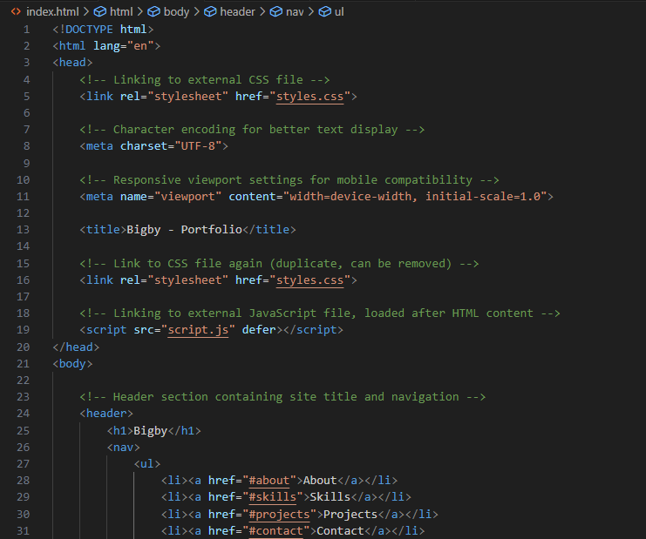
Structuring a Web Page (HTML Basics)

Figure 1: Showing a glimpse of the HTML code.

Styling the Web Page (CSS Basics)
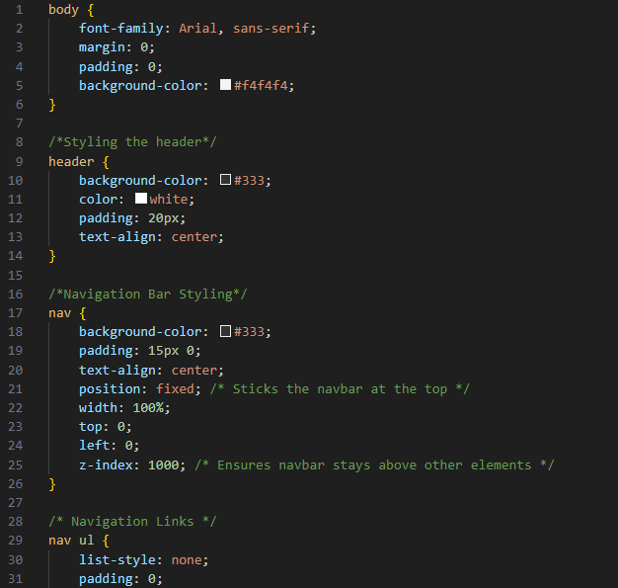

Figure 2: Showing the screenshot of the CSS code.

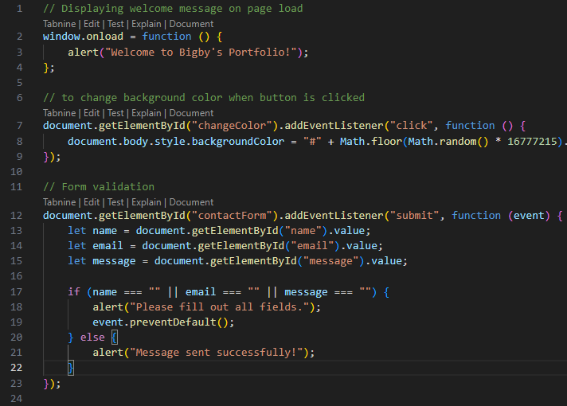
Enhancing Functionality with JavaScript

Figure 3: Showing a glimpse of JavaScript code for interactivity.

Publishing the Web Page
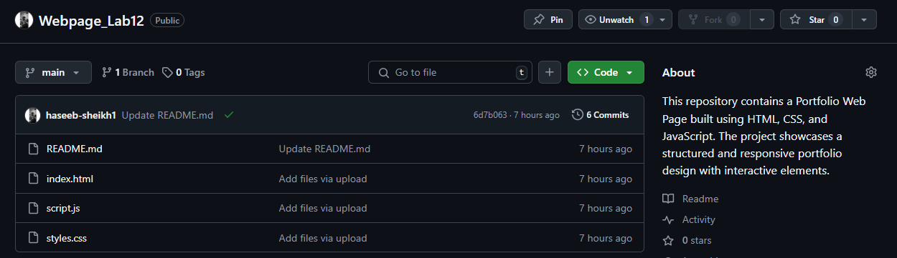

Figure 4: Showing the screenshot of the GitHub repository with the README file.


Figure 5: Showing the URL of the live site.

